# Constructive review of a deficient user interface

* Outline

That interface is from a program called “Freemake Video Converter”. This program allows you to convert videos from one format to another one. You can also convert music or pictures and the program can work as a basic video editor because you can add more than one video, split or join them and put a soundtrack.

* Description of the interface

First of all, we are going to describe the interface. As we can see on the picture below, at the top of the interface we have 5 buttons in order to choose the type of media that we want to import to the program. We also have a button to active or not the mix of the videos.

In the middle of the interface there is a box where all the media that we import is displayed.

At the bottom part we can find the formats of the output video and we can shift with the arrows.

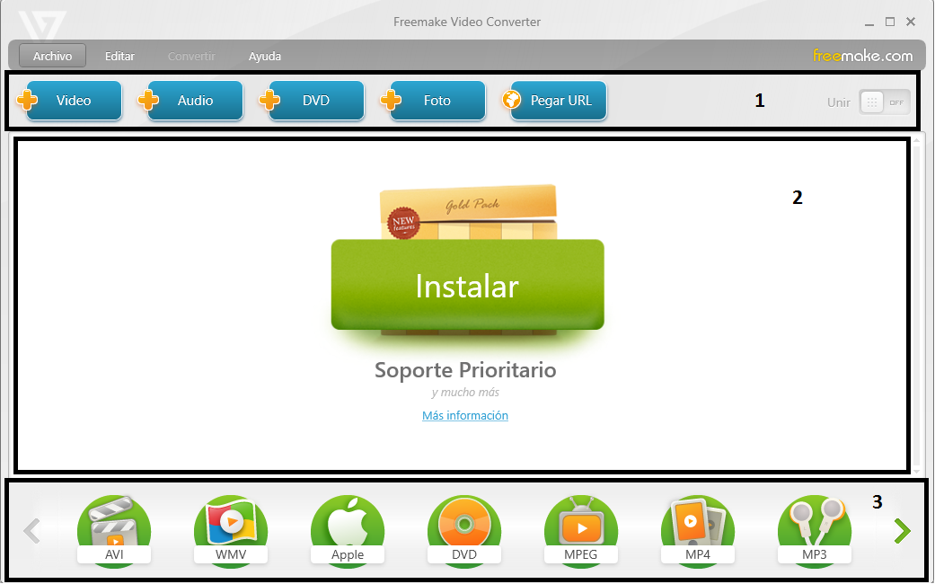

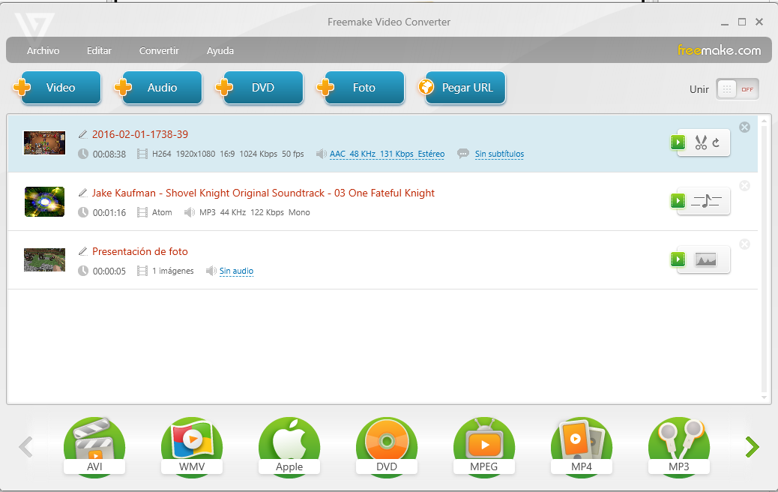

When we add media to the program, the program shows the content on the middle box and depending on the type of media (picture, video or song) the button that is on the right side of each element is adapted to each one.

With these buttons we can modify the file that we have imported, for example, if the file is a video or a song we can shorten them.

So, we can say that the interface is dynamic because the code of the program adapts the interface to different possible cases.

* Enhancements and justification

The first thing that in my opinion we have to improve is the first box (add video, audio, DVD…)

It doesn’t matter the type of media that we import, so I think that it’s much better to put only a button for example in the center of the middle box with the text “Import” or “Add” and then you can choose any type of media you want and allows you to use drag-and-drop function also. That improvement reduces the use of time that you spend using the interface and also the accessibility.

Second point to improve is the green button that says “Instalar”. If you press that button the program takes you to a website in order to install another program. In other words, advertisements.

These green button can confuse you if you think that the button is for import media to the program so I think it’s better to remove it or change the behavior.

Last thing I would improve is the third box, the one that allows you to choose the output format. It’s very annoying to use the arrows to swift between a lot of formats and you waste so much time looking for the format you want. So in my opinion I would use for that a list box or a pull-down list with all the elements that allows you to find the desired format faster.